**Check List for Lava Penetrometer Operation**

**Equipment Assembly**

- attach short tubes (penetration and displacement) with pins at the quick release connectors

- ensure that the displacement rod is not blocked by the hemisphere tip and slides through the bearings

- if necessary move the bearing so that the washer reaches it before the target hits the distance sensor

- slide the force gauge onto the stabilizing bar and on the end of the penetration tube, lock it with red-cap screws onto the stabilizing bar and with brass (golden) screws on the tube

- attach the electronic box to the stand with two brass (golden) screws

- connect distance sensor wire inside the electronic box through the black hole connect to an open 4-channel i2c port

- connect the force gauge wire (macro-USB) from electronic box to the port on the top of the force gauge

- place power bank in electronic box with velcro-tape

- screw the handles onto the stabilizing bar according to your convenience (2 below by sliding the clips and one on the side by screwing it directly into the clip)

-ensure the penetrometer hemisphere tip is fastened with a steel wire

**Operation Procedure**

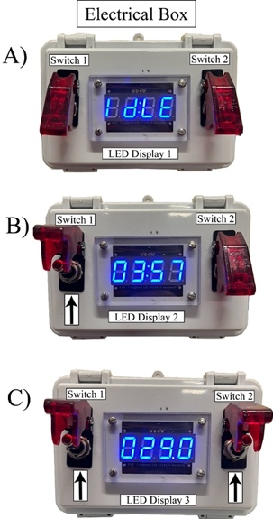- make sure both flip-switches are pointing down

- turn on the force gauge

- connect the power supply cord from electronic box (USB) to the power bank

- check that a green light appears on the distance sensor

- wait ~30 seconds until the LED lights up and displays “IDLE” (A)

- flip up the left switch, the LED should now display the time (ex. “03:57”) (B)

- flip up the right switch, and the LED should now display live (fluctuating) force data (ex. “029.0”) (C)

- flip the switches down, and repeat the sequence to make sure everything works

**For Measurement**

- make sure you have a bucket of water nearby

- tare the force gauge (zero button on the gauge) at the approximate angle you plan to do the measurement at.

- flip both switches up, making a note of the time reported from the LED (this is what the data file will be marked as).

- Data is only acquired when both switches are flipped up!!

- approach the lava and place the instrument near the lava to pre-heat the tip

- position the hemisphere on molten lava and the washer on a piece of lava crust, and push with steady force into the lava (~2-15 seconds), until the displacement rod is maximized (~15cm).

- remove the penetrometer from the lava, and repeat the measurement if possible within the same area

- if lava sticks to the hemisphere, dip it into the water bucket

- when finished in a site, flip both switches down and return the LED to “IDLE”

- To power off, simply unplug the power supply cord from the power bank

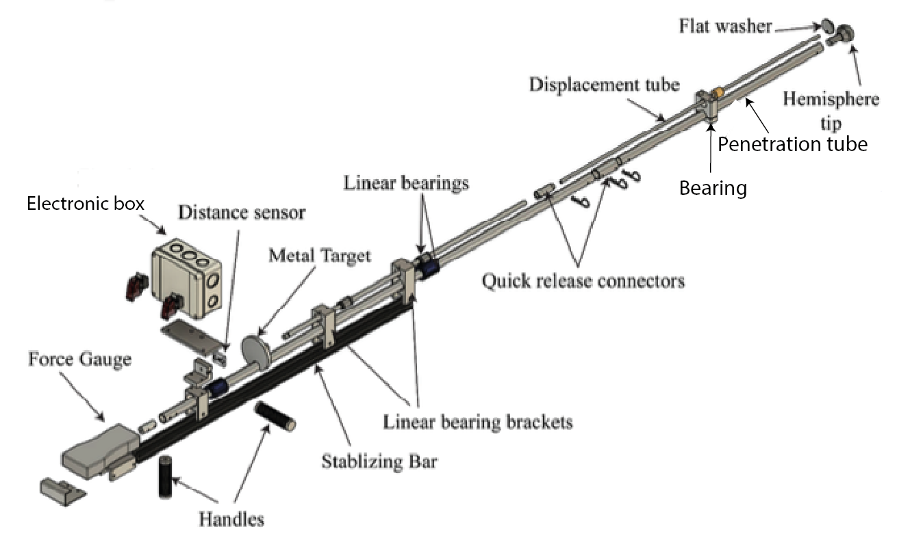

Field Use Example Photos

*Note version in photos does not have flip switches*



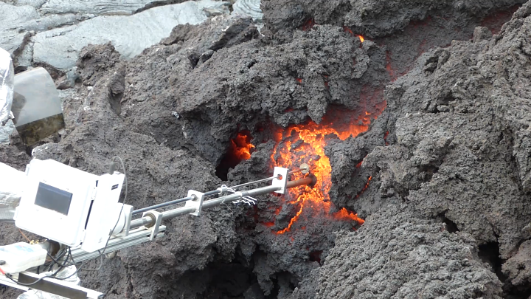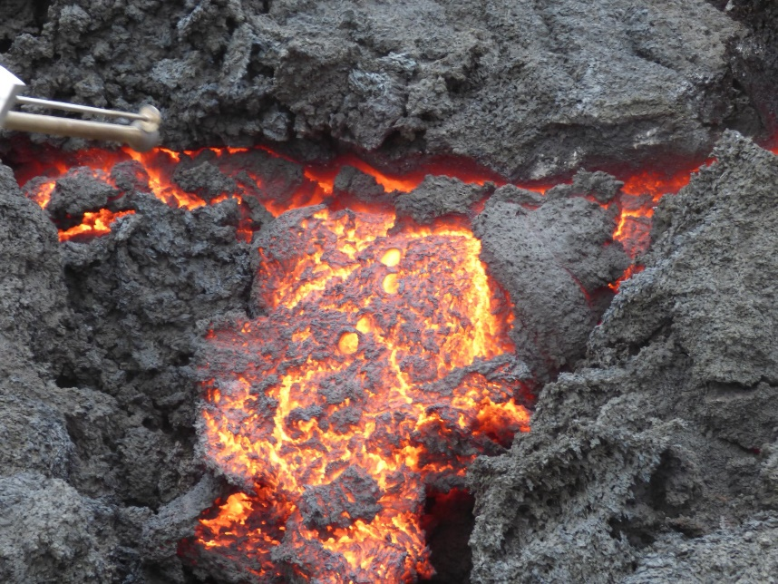

**Additional Helpful Tools and Information**

The lava penetromter does not have a graphical display for the Raspberry Pi operating system in the field. However, there are methods for connecting your cellphone to the Raspberry Pi directly, where you can access files and monitor codes execution via the device terminal.

One option is the phone app : RaspController (available free for iOS and Android at their respective app stores).

To get RaspController working, you will need to connect the Raspberry Pi to a monitor (HDMI) and add your phone as a hot spot known network.

You will see a message on the Pi saying connected to xxx phone IP : xxx.xx.xx.x

You can then go to the RaspController app and add device with the + symbol.

You will add a :

Device name : Your choice of name of the device

Host/IP Address: use the 8 digit value from the Pi device reported from the connection to your phone network (xxx.xx.xx.x)

SSH Port : 22 (default)

Timeout (sec) : 15 (default)

Username : lavapub (this is the name of the Pi and can be changed in the device settings if preferred)

Authentication: Password

Password : LP2022 !! (again this is what the Pi is set with, and can be changed within the operating system settings).

You can test the connection and it will either say :

Connection OK

Or

Attention! Authentication Failed.

If OK, you need to press save in the upper right and then all the details will be stored within the app under the device name given.

If failed, you may need to check that the IP address, username, password are correct AND that your phone is connected via hotspot to the Raspi

Once connected to the device, you will see options to access a number of tabs including File Manager, SSH Shell (terminal) etc.

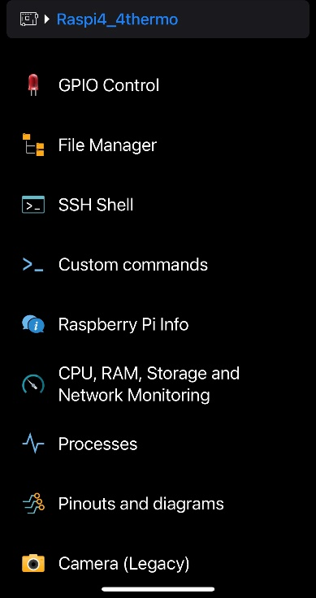

To access the files directly on your phone, you can navigate to through the File Manager 🡪 Desktop 🡪 Pen_data

Where you will see all the date-time-stamped files.

You can save the files directly to your phone by selecting a file (holding down your finger), the press share button (see below) and navigate to a desired location on your phone device (such as downloads, icloud, etc).

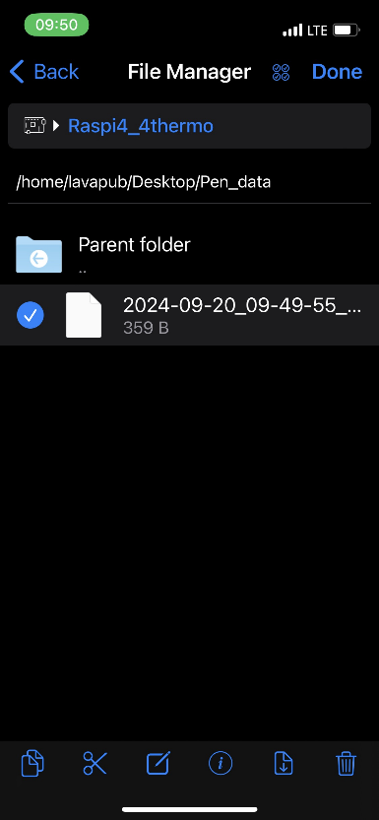

Once on your phone, you can email to yourself or other researchers for rapid data processing

See: <https://github.com/LAVAPUBMH/Lava_Field_Penetrometer>

For all codes needed for processing.